Implement program to apply moving average smoothing for data preparation and time series forecasting.
EX:No.6
DATE: 01/03/25

AIM:
To implement program to apply moving average smoothing for data preparation and time series forecasting.

OBJECTIVE:
To smooth and prepare office supply sales time series data using moving average smoothing techniques to reduce noise, highlight trends, and support basic forecasting.

BACKGROUND:
- Time series data often contains short-term fluctuations that make trends difficult to observe.
- Moving average smoothing reduces this noise by averaging data points over a fixed window, making trends more visible.
- This smoothed version is easier to analyze and can serve as a foundation for forecasting models.
- Proper data preparation improves the accuracy and interpretability of time series forecasts.

SCOPEOFTHEPROGRAM:

- Load and clean the office supply sales dataset
- Set the datetime column as the index
- Aggregate sales data by daily frequency
- Apply 30-day moving average smoothing to reduce short-term fluctuations
- Visualize the original vs. smoothed time series to interpret sales trends

ALGORITHM:

- Import required libraries (pandas, matplotlib)
- Load the dataset and convert the date column to datetime format
- Set the date column as the index of the DataFrame
- Resample the data to obtain daily total sales
- Apply moving average smoothing using a 30-day window
- Plot the original and smoothed series for visual comparison

CODE:

import pandas as pd
import matplotlib.pyplot as plt

# Load your AirPassengers dataset
df = pd.read_csv("/mnt/data/AirPassengers (1).csv")

# Display the first few rows to confirm column names
print(df.head())

# Convert 'Month' column to datetime format
df['Month'] = pd.to_datetime(df['Month'], format='%Y-%m')

# Set 'Month' as the index
df.set_index('Month', inplace=True)

# Rename the passenger column if needed
df.rename(columns={df.columns[0]: 'Passengers'}, inplace=True)

# Resample monthly data (though it's already monthly, just in case)
df_monthly = df['Passengers'].resample('M').sum()

# Apply Moving Average Smoothing (e.g., 12-month window)
window_size = 12
df_smooth = df_monthly.to_frame(name='Passengers')
df_smooth['Moving_Avg'] = df_smooth['Passengers'].rolling(window=window_size).mean()

# Plot the original and smoothed time series
plt.figure(figsize=(14, 6))
plt.plot(df_smooth['Passengers'], label='Original Passenger Count', alpha=0.4)
plt.plot(df_smooth['Moving_Avg'], label=f'{window_size}-Month Moving Average', color='red')
plt.xlabel("Date")
plt.ylabel("Number of Passengers")
plt.title("Air Passenger Trend Estimation using Moving Average Smoothing")
plt.legend()
plt.tight_layout()
plt.show()

OUTPUT:

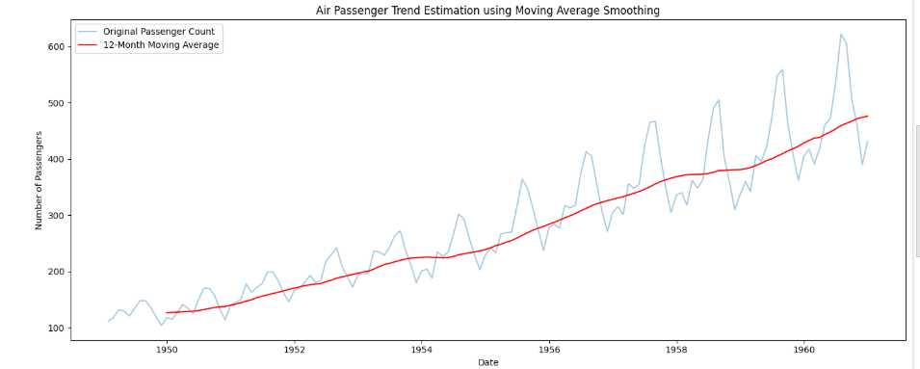

RESULT:
Thus,theprogramto apply moving average smoothing for data preparation and time series forecastinghasbeendone successfully.

